AI-Powered Resume Screening & Candidate Ranking System

Internship Project Report
1. Introduction
Recruitment is a critical process for organizations seeking qualified candidates. Modern organizations receive a large number of applications for each job opening, making manual resume screening both time-consuming and inefficient.
To address this challenge, an AI-powered Resume Screening and Candidate Ranking System was developed. The system automates resume evaluation by extracting relevant information, comparing candidate profiles against job descriptions, and ranking applicants according to their suitability.
The project combines Natural Language Processing (NLP), Machine Learning techniques, and automated decision logic to simulate the core functionality of modern Applicant Tracking Systems (ATS).

2. Problem Statement
Recruiters often spend significant time reviewing resumes manually. This process can introduce inconsistencies, delays, and subjective bias.
The objective of this project is to develop an automated screening system capable of:
- Reading resumes from multiple formats
- Extracting relevant information
- Understanding job requirements
- Matching candidate profiles against job descriptions
- Ranking candidates automatically

3. Objectives
The primary objectives of this project are:
- Build an end-to-end NLP pipeline
- Extract structured information from unstructured resumes
- Calculate resume-job similarity
- Generate candidate relevance scores
- Rank applicants automatically
- Reduce recruiter effort

4. Dataset Description
The project utilizes a publicly available Resume Dataset obtained from Kaggle.
Dataset Details:
- Total Records: 586
- Format: CSV
- Main Columns:

  - ID
  - Resume_str
  - Resume_html
  - Category

Categories include:

- Information Technology
- Engineering
- Finance
- Banking
- Consultant
- Agriculture
- Healthcare
- Sales
- HR
- Public Relations

In addition to the CSV dataset, PDF resumes and manually entered resume text were used to validate the system.

5. System Architecture
The overall workflow of the system is illustrated below:

6. Methodology
6.1 Resume Ingestion
The system accepts resumes through three different input methods:
- CSV dataset upload
- PDF resume upload
- Direct text input
This design improves flexibility and supports multiple real-world use cases.
6.2 Text Preprocessing
The extracted resume text undergoes preprocessing steps:
- Conversion to lowercase
- Removal of special characters
- Stopword removal
- Lemmatization
These steps improve text quality and prepare the data for feature extraction.
6.3 Skill Extraction
A predefined technical skill dictionary is used to identify important skills within resumes and job descriptions.
Examples include:

- Python
- SQL
- Machine Learning
- Deep Learning
- TensorFlow
- NLP
- Git
- Docker

6.4 Experience Extraction
Regular expression-based pattern matching is used to identify years of experience mentioned in resumes.
6.5 Feature Engineering
Three major features are generated:

- Skill Match Score
- Experience Score
- Similarity Score

These features collectively determine candidate relevance.
6.6 Similarity Scoring
TF-IDF Vectorization converts text into numerical vectors.
Cosine Similarity is then used to measure similarity between candidate resumes and job descriptions.
6.7 Candidate Ranking
Final candidate scores are calculated using weighted scoring.
Candidates are sorted in descending order according to their final scores.

7. Streamlit Dashboard
A Streamlit-based dashboard was developed to provide an interactive user interface.
Features include:

- Resume Upload
- Job Description Input
- Candidate Ranking
- Skill Gap Analysis
- Downloadable Results

The dashboard enables recruiters to evaluate resumes without interacting directly with the codebase.
8. Results
The developed system successfully:
- Parsed resumes from multiple formats
- Extracted skills and experience
- Calculated resume-job similarity
- Generated candidate rankings
- Identified missing skills
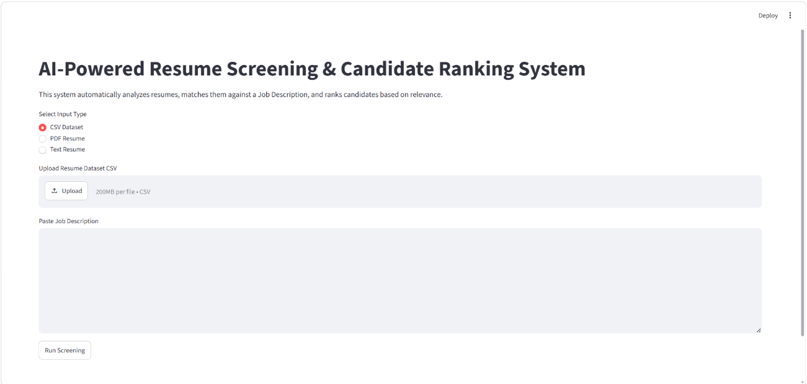
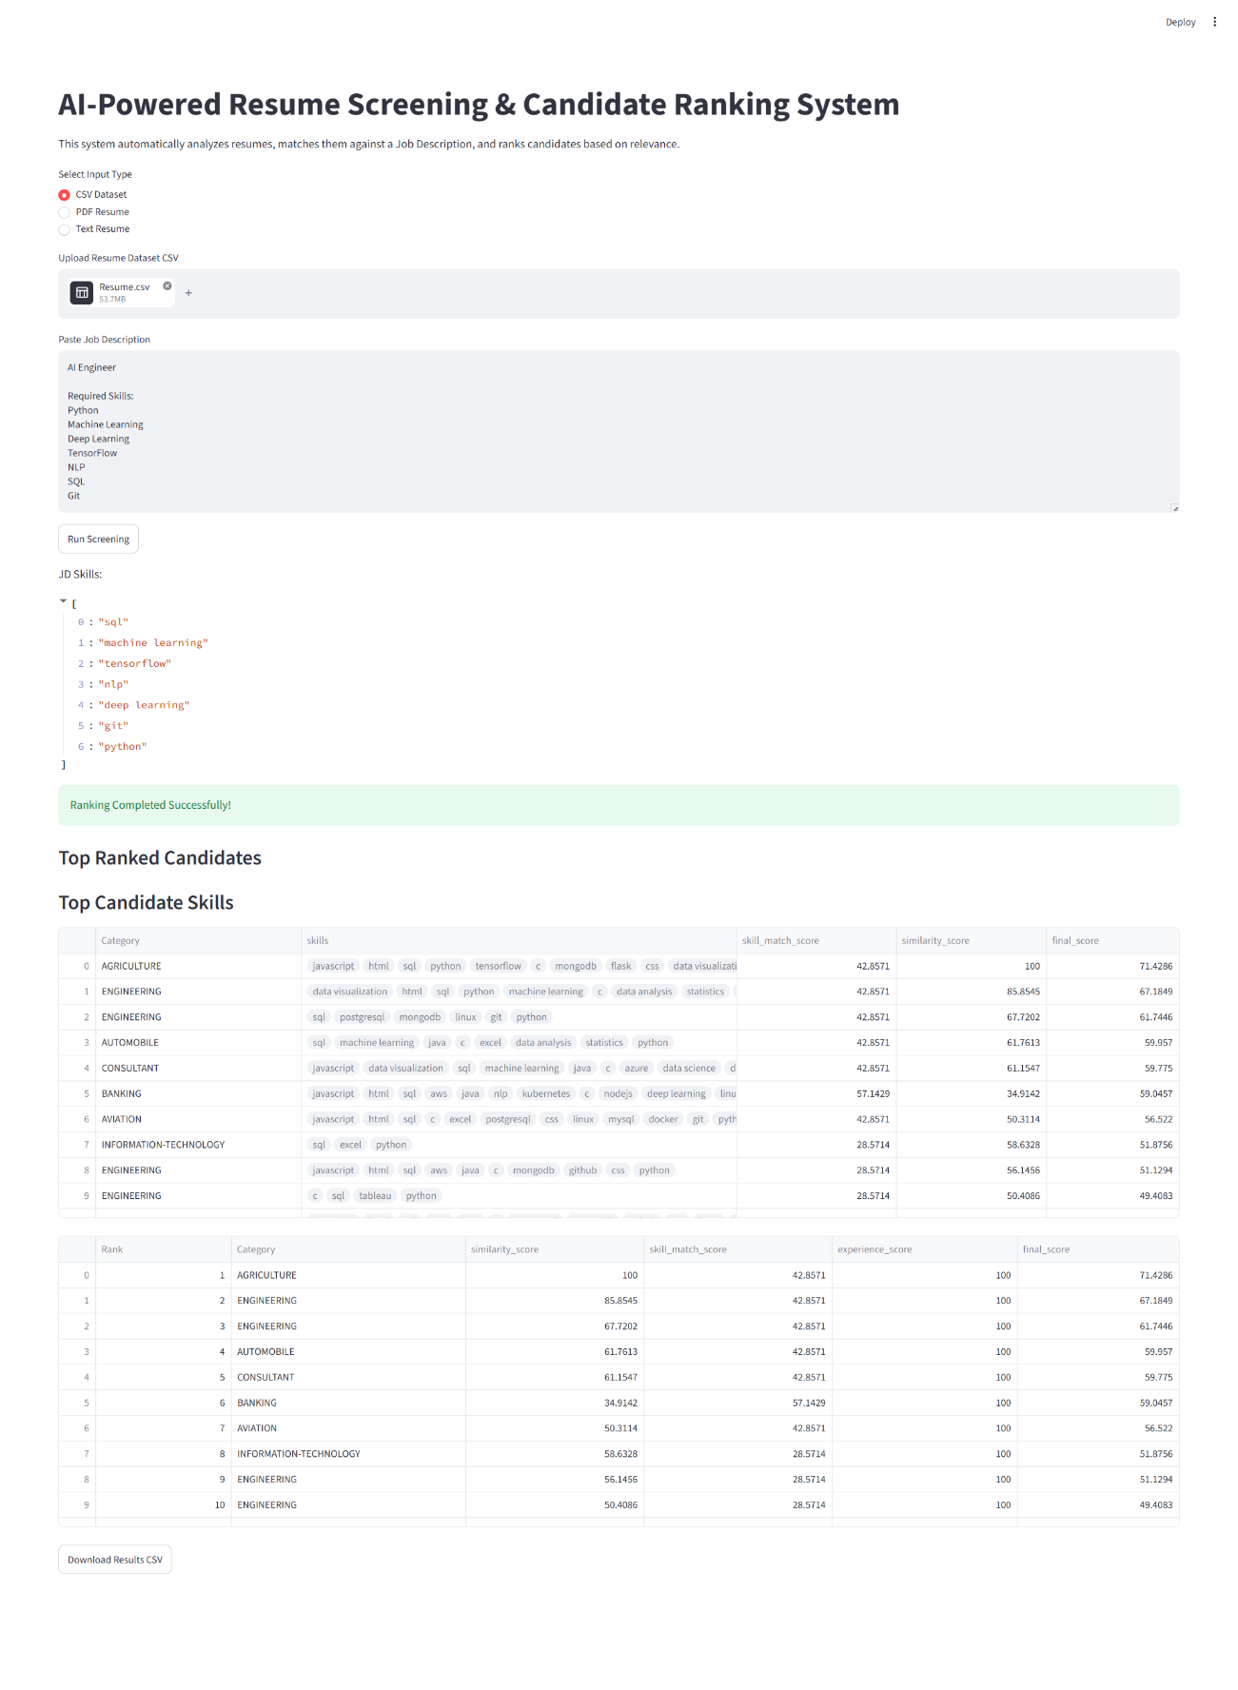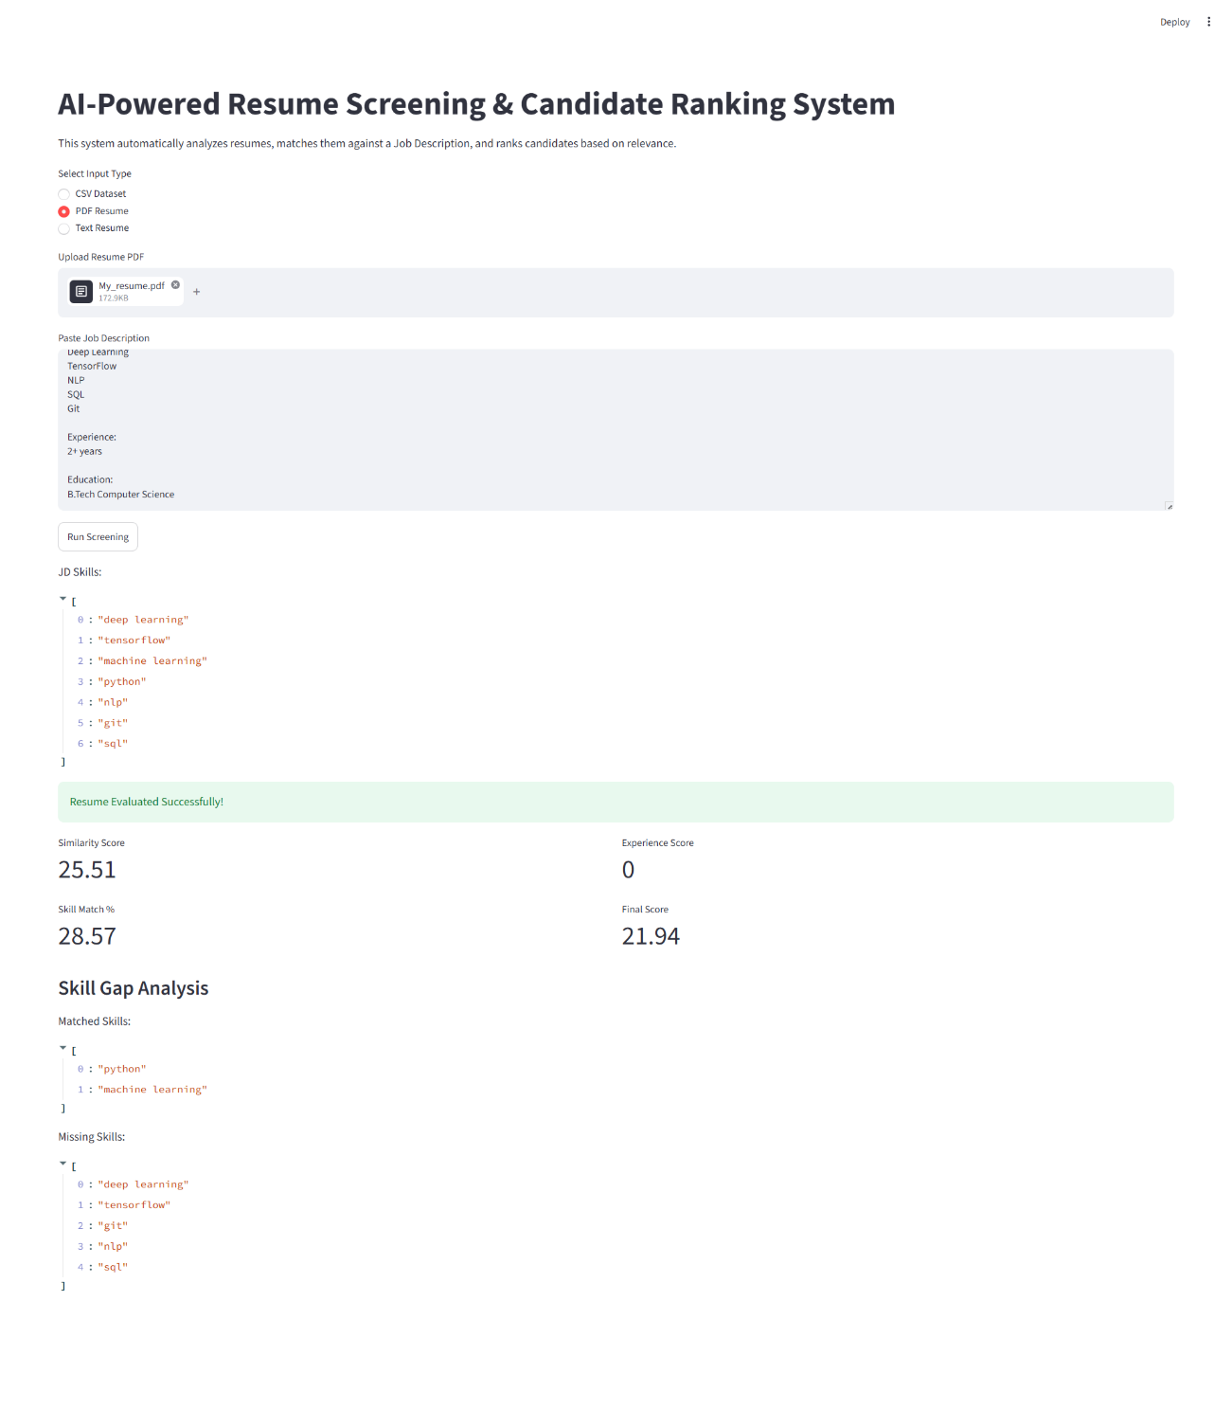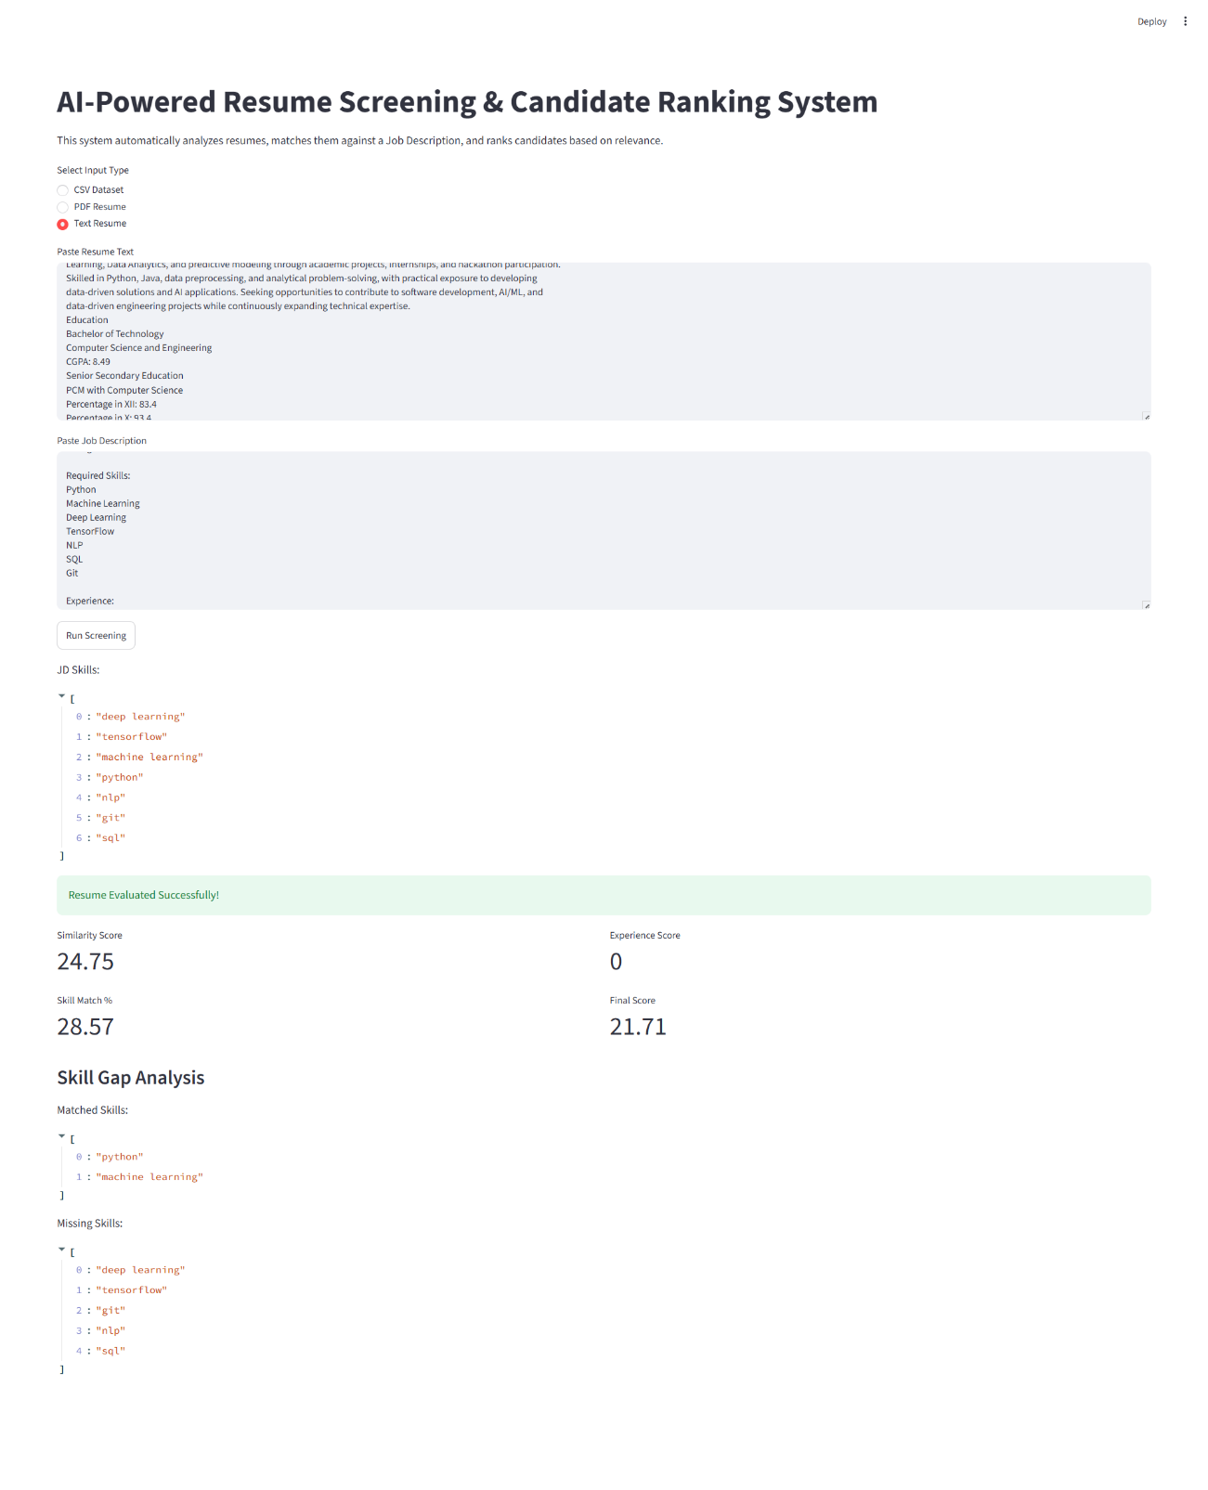
The ranking mechanism effectively prioritized resumes with higher relevance to the provided job description.

9. Limitations
Despite achieving the project objectives, several limitations remain:
- Skill extraction relies on predefined dictionaries
- Experience extraction depends on textual patterns
- TF-IDF does not capture deep semantic meaning
- Dataset category labels may contain inconsistencies
- Contextual understanding is limited compared to modern LLMs

10. Future Enhancements
Potential future improvements include:
- BERT-based semantic matching
- Sentence Transformer embeddings
- Resume summarization using LLMs
- Named Entity Recognition (NER)
- Recruiter feedback integration
- Bias detection and fairness evaluation
- Multi-job comparison support

11. Conclusion
The AI-Powered Resume Screening and Candidate Ranking System successfully demonstrates the application of NLP and Machine Learning techniques in recruitment automation.
The system supports multiple resume formats, performs automated candidate evaluation, and provides recruiter-friendly ranking outputs through a Streamlit dashboard. The project represents a practical implementation of ATS-inspired technology and serves as a strong foundation for future enhancements involving advanced NLP and Large Language Models.

